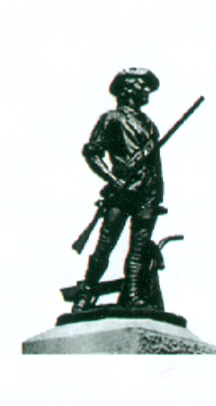
Guardians of the National Cemetery
OFFICIAL SUPPORT COMMITTEE FOR
WASHINGTON CROSSING NATIONAL CEMETERY
P.O. Box 233
NEWTOWN, PENNSYLVANIA 18940
Robert E. Craven
President

Gabriel Mascio
Vice President

Daniel Worden
Secretary

John Heenan
Treasurer

Gregory Ritz
Asst Treasurer

Eugene Hamilton
Director &
Honor Guard Commander

Board of Directors

20 June 2023
To whom it may concern:

I write today to recommend Jennifer Frudakis-Petry as a dedicated, professional sculptor, and more. Jennifer actually handled many important tasks for our project and did them all well, on time and within budget.

Our organization commissioned Jennifer to produce a bronze statue of General George Washington at Prayer. The statue was to be approximately 150% of life-size atop a three-foot-high base, placed within a National Veterans Cemetery. The project started during the COVID 19 pandemic lockdowns; Jennifer kept everyone on schedule even with supply chain problems. She coordinated with the foundry on the final production and on the actual delivery and installation.

Jennifer researched the subject more thoroughly than anyone could have envisioned to ensure an accurate likeness of General Washington and she completed a statue which portrayed the sincere passion which we believe the General had for his troop and for our nation. Furthermore, she educated a number of old veterans about how statues are made; we are not artists, but we do know how to recognize a job well done.
Our statue was dedicated and donated to the National Cemetery Administration of the Veterans Administration on 20 May 2023 with Marine Corps General John F. Kelly as our keynote speaker.

I am pleased to write this letter and would be happy to share further thoughts at any time; you may feel free to call at 215-485-5963.

The Guardians of the National Cemetery is the official support organization for Washington Crossing National Cemetery which opened in January 2010. Since then our Honor Guard has provided full military honors for virtually every veteran interred there (over 20,000 to date) without ever missing a mission. Our Honor Guard is made up of honorably discharged, dedicated veterans whose average age is in the mid/upper-seventies.

Sincerely,

John C. Heenan
Treasurer and Chairman of the Monument Committee
215-485-5963

Cc: Robert E. Craven

